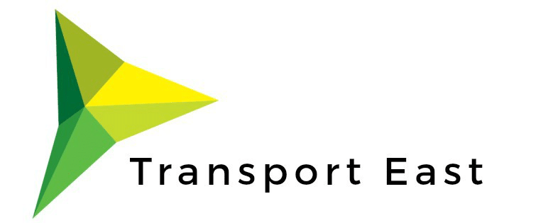

Transport East

Transport for a Greener World Competition
The year 2050 might seem a long way away, but if we want to improve the air we breathe and our impact on climate change, we need to start planning for change now.
Did you know that 40% of the carbon emissions we produce come from how we travel? At Transport East, we want to change that.
To make this change, we need your ideas to help create a cleaner, greener and healthier region for us all.
To do this, we are hosting a creative writing/arts competition for you to tell us what you would like for the future of travel near your home. The theme is “transport for a greener world”and we would like to see you get creative with your entries.
Transport East aims to make traveling around your area as easy and sustainable as possible. To do this, we are making a plan for the region called our Transport Strategy. We would like to include your ideas as part of this.

About the competition

Who can take part?
The competition is open to all young people in school years 7, 8 and 9 living or going to school in Norfolk, Suffolk, Essex, Southend-on-Sea and Thurrock.

Competition Guidelines
Choose ONE of the following:
• A poem, story, song, or rap about what you would like to see as the future of transport (500 words maximum). This can be submitted as a written document or video.
• A drawing, painting or collage to show what you would like to see as the future of transport (one side of A4). This can be completed by hand or on a computer.
The winning entries will think carefully about how their future transport ideas will impact the environment and climate change. We recommend focusing on sustainable transport ideas to support the region.
Your idea can explore a specific type of transport or a way of travelling, or it can highlight something you have seen where you live that could be improved to better the environment.

Deadlines
All entries must be submitted by 3rd May 2021.
These should be emailed to TransportEast@suffolk.gov.uk as a photo, image, PDF, or word document.
Please remember to include your name and the name of your school with your entry.

Prize
£20 Waterstones gift voucher to each winner
Five winners will be selected from across the region.

All entries must be original and entirely that of the young person. Only one entry may be submitted per person.
The decision of the judges will be final.
By entering you give permission for Transport East to use your entry as part of their communications materials, including on their website and on any documents.
Your privacy is important to us, please see our privacy policy

