  - Transport East Board Meeting
  - Monday 20th January 2025
  - Via Teams
Attendees
Core Members |  | TESOG Officers |  | Observers
Will Quince | Transport East Chair | Andrew Summers | Transport East | Liz Smith | DfT
Cllr Graham Plant | Norfolk County Council (VC) | Esme Yuill | Transport East | Dan Taylor | DfT
Cllr Lesley Wagland | Essex County Council | Suzanne Buck | Transport East | Hugo Fulford | DfT
Cllr Chris Chambers | Suffolk County Council | Richard Doleman | Norfolk County Council | Robin Gisby | DfT Operations
Cllr Phil Wittam | Suffolk District Rep | Alastair Southgate | Essex County Council | Jack Weaver | Norfolk Chambers
Cllr Graham Butland | Essex District Rep | Sara Noonan | Suffolk District Rep | Paul Crick | Thurrock County Council
Cllr Cowan | Southend City Council | Luke Barber | Suffolk County Council | Neil Hoskins | Southend City Council
Cllr Holloway | Thurrock Council | Karen Gearing | Southend City Council | Richard Lumley | Southend City Council
Cllr Alexander Nicoll | East West Rail Eastern Board Chair | Nav Tung | Thurrock County Council | Chris Starkie | Norfolk County Council
 |  | Graeme Mateer | Suffolk County Council
 |  | Mark Lucas | UK Innovation Corridor
 |  | Matthew Stewart | EEGLA
 |  | Trevor Wiggett | Norfolk District Rep
 |  | Matthew Taylor | National Highways
 |  | Tom Cornwell | National Highways

Apologies
Cllr Tim Adams | Norfolk District Rep | Phil Bibby | Hertfordshire County Council

 | Welcome & Introductions  Chair thanked everyone for attending the Summit on 16th January in Ipswich. A successful day with over 100 attendees supporting the ambitions of the East. Feedback from the Minister, Simon Lightwood MP and DfT colleagues was encouraging, and the East was well represented. | Actions
 | Minutes from last meeting on 25th October 2025 No comments, all actioned are in progress.
Department for Transport Update
Dan Taylor, Deputy Director, Regional Partnerships and Delivery, DfT summary key activity.
- The new Secretary of State, Heidi Alexander, has maintained her focus on rail and bus reform, and devolution.
- The Integrated National Transport Strategy is continuing, with regional roadshow events planned for February.
- The second phase of the Spending Review, which will set budgets for 2026-2027 and beyond is ongoing, Dan emphasizes the tight fiscal environment we are still in, however there is no plan to include new tax-raising or revenue-raising measures in the Spending Review.
- The devolution and local government reform White Paper which was published in December was welcomed, and there needs to be a focus on its opportunities rather than challenges. DfT recognise there are still complex details to be addressed and that the paper is the framework for new combined authorities and local government reform. Local government reform is noted as having an impact on transport and MHCLG recognises this. STBs were noted has having a role in transport powers within the White Paper.
- The Public Ownership: Railways Passenger Service Bill received Royal Assent in November and SoS launched the transition of privately owned operators into public ownership in December. Southwestern Railways and C2C will be the first to come over in mid-2025 with Greater Anglia to follow autumn 2025.
- The importance of continuing to work with Transport East colleagues on transport priorities remains.
- Echoes the positive feedback on the Summit, noting the good input and conversation.

 | Nationalisation of Rail Services: Greater Anglia and C2C  Robin Gisby, Chief Executive, Department for Transport Operator Ltd (Rail) updated colleagues on the latest developments in the Governments plans to nationalise the railways.  - DfT Operations Ltd was established as an operator of last resort. It is a holding company owned by the Government to manage the transition of train operators into public ownership. Southwestern, C2C and Greater Anglia are the first train operators to move across to public ownership. DfTO are working closely with their respective management teams to ensure a smooth transition and maintain the high levels of service.  - DfTO work closely with Network Rail and will be interfacing with GBRTT, STBs, Mayors and other interested parties in the coming months.  - Reform will take place to ensure a more integrated accessible service for passengers with better ticketing options.  - Recognised the strong performances of GA and C2C and referenced that these franchises were not in the same place as others that have been nationalised due to poor performance.  - Integration does not mean destabilisation of the network in the East. The investment that has been seen over recent years by GA will remain in the East and lessons will be shared.  Comments & Discussion  - Chair: Raised concerns about maintaining the high level of reliability in Greater Anglia's rail services, given the significant investment in new trains. Robin acknowledges the importance of retaining the management team, addressing fragile deals with drivers, and working orders. DfTO will focus on maintaining the current level of service and avoiding changes that could compromise reliability.  - Robin emphasised the importance of learning from high-performing operators and applying best practices to other regions.  - Cllr Nicol: Welcomed Robin’s comments on the future of rail however raised concerns that they are potential shortfalls in funding for rail and there is still uncertain around Ely and Haughley Junctions.  - Driver challenges remain, and further work will be undertaken to address this.  - EWR is in a good place, but we must make better use of the funds we have available to us.  - Broader challenges on freight remain and removing freight from commuter lines is important.  - Robin noted that the construction of Sizewell C nuclear facility could pose a problem for rail.  - Ticket office challenges remain, and more flexible integrated approach is needed.  - Mark Lucas: raised concerns about the suitability of roll-stock and the potential challenges facing DfTO in tackling this. A rolling stock strategy is needed across the country and by the end of the year 7 out of 14 train operators will be under DfTO control, addressing this can then be done at a national level.  - Cllr Wagland: There is a social value element to ticketing and staffing at train stations that need to be recognised and supported.  - Paul Simon: Suffolk Chamber of Commerce manages the supply chain to Sizewell C and would welcome any support that DfTO can give to relighting communication between SCoC and Government. | Robin to facilitate a meeting between DZES and Suffolk Chamber of Commerce.
Transport East Business Unit Update (paper attached)
Andrew Summers, Chief Executive, Transport East

PART A: Devolution White Paper & Transport East Enabling Powers Consultation

Andrew summarised the key feedback received from The Transport East enabling powers consultation. The consultation showed support for aligning with the devolution White Paper and all five local transport authorities in the region have applied to join the devolution priority program, (DPP) with approval leading to two Mayoral Strategic Authorities being created, with Mayoral elections planned for May 2026.

Key Points:
- The enabling powers consultation held before Christmas showed strong support for the concept of TE having more powers.
- Strong support for Strategic Rail and Capital Grants
- Fifty percent or more support for Buses, Integrated Ticketing and Strategic Roads
- General support for securing enabling powers to improve transport, support the economy, society, and environment.

Board members were asked to endorse the following.

- TE Chair to write to our sponsor DfT Minister to report the results from the consultation (a) outlining the partnership’s level of support for securing the benefits of enabling powers for strategic transport in the East and (b) subsequently offer the Transport East’s strategic support in co-designing strategic transport devolution in the East through MCAs and the STB.
- TE Chair contacts Local Transport Authority Leaders to offer our full support in the next phases of devolution.
- TE Chief Executive works with the Transport East Local Authority Directors Group, and local authority Chief Executives, to agree a process to co-design and develop the next stage of the TE enabling powers and long-term plans alongside the planning for MSAs and Local Government Reform.

Board agreed and a further update will be given at the Board meeting in March.

PART B: 2025/26 Business Planning scenarios submission for DfT

Andrew summarised the three funding options that Transport East have developed based the on guidance from DfT (see below table) Transport East will focus on maximizing the work already completed and amplifying the benefits in a transitional year, ahead of the 3-year CSR in the spring.
The business plan will be submitted to DfT on 21st January and a following up meeting is planned for 28th January to talk through the options.

The business plan was endorsed without comment, and we wait to hear on the funding envelope.

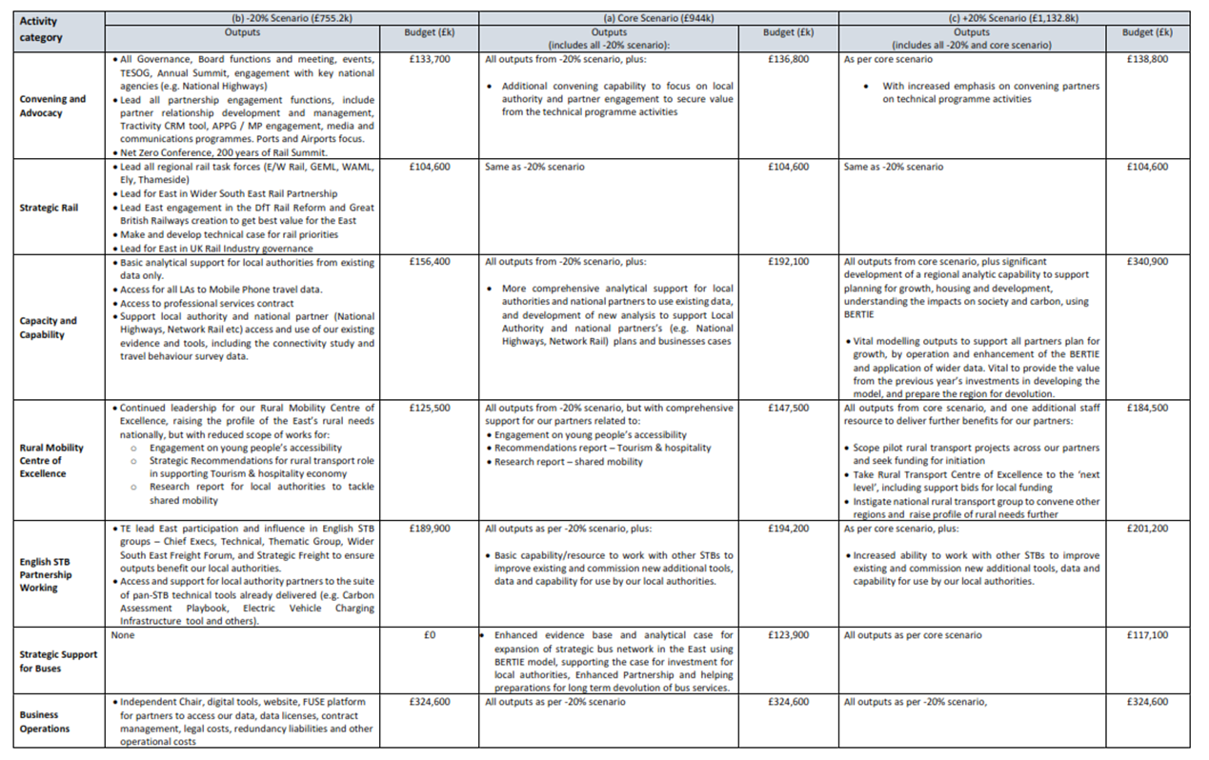

Comprehensive Spending Review
Suzanne Buck, Head of Strategic & Technical Programme summarised the draft CSR submission document which will be submitted via the HMT portal on the 7th February. The reports have two main sections.
- Supporting Local People: Helping local authorities to deliver for communities and business
- Supporting Growth: Deliver regionally and nationally significant housing and economic growth.
The documents set out the regional asks, the advocacy approach that will be undertaken and key infrastructure projects. Work will be started to coordinate with partner bodies, including The East of England All-Party Parliamentary Group and TE neighbouring STB England’s Economic Heartland.
Key regional asks:
- Changing the way funding is provided and governed. A multi-year funding settlement, equitable distribution of funds, and risk-sharing with government.
- Funding to deliver MRN/LLM, SRN and Rail schemes. 11 priority delivery schemes were identified and a further 7 schemes identified for development funding.
- Funding to support Ely area capacity enhancement and Haughley Junction: Finalise plan and progress planning consent.
- Funding to support development of the region’s pipeline.
Next Steps:
Board members were asked to review the document and advise Suzanne of any comments by COP on Friday 24th January.

Transport East Consultation Responses:
Suzanne Buck, Head of Strategy & Technical Programme
Transport East asked the Board to approve their consultation responses to the following consultations.
East West Rail Non – Statutory Consultation: Endorsed (with updated wording from Cllr Alexander Nicoll)

- The report supports the vision of direct east-west coast-to-coast rail connectivity and the East West Rail Project.
- Recommends extending the proposed double track towards Newmarket for early benefits and the opportunity for a new station.
- Emphasizes the need for full electrification and the removal of new level-crossings while maintaining walking, cycling, and wheeling connectivity.
- Submission due 24th January

Integrated National Transport Strategy: Call for Evidence – Endorsed (Submission date delayed by Government)
- The consultation outlines call for ideas, focusing on a high-level direction for transport over the next 10 years.
- Emphasises the importance of cross-sector collaboration and integration with spatial planning.
- Highlights the need for integrated ticketing and payment systems, multi-modal hubs, and real-time data sharing.
- Discusses the importance of transport assessments, social value, and devolution of powers to the most appropriate level.
- Regional DfT Roadshows planned for TE region in Ipswich on 19th February.

Transport Select Committee Call for Evidence: Buses Connecting Communities - Noted
- Emphasises the need for franchising solutions in rural areas and the resourcing required to implement them.
- Highlights the importance of addressing the social and economic consequences of poor connectivity, particularly in rural areas.
- Discusses the challenges faced by rural areas and the need for alternative modes of transport solutions.
- Submitted 17th January 2025

Comments & Discussion

- Cllr Alexander Nicoll & Christ Starkie: EWR response updated to include how important the Eastern Section of EWR is. Further discussion and confirmation of wording to be agreed at EWR Eastern Section Board Meeting later today.

 | Meeting Close

